**Exercise 17: More Files**

1. This script is *really* annoying. There's no need to ask you before doing the copy, and it prints too much out to the screen. Try to make the script more friendly to use by removing features.

**from_file, to_file = ARGV**

**puts "Copying from #{from_file} to #{to_file}"**

**in_file = open(from_file)**

**indata = in_file.read**

**puts "The input file is #{indata.length} bytes long"**

**puts "Does the output file exist? #{File.exist?(to_file)}"**

**puts "Ready, hit RETURN to continue, CTRL-C to abort."**

**$stdin.gets**

**puts "Alright, all done."**

**in_file.close**

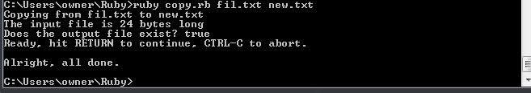

1. See how short you can make the script. I could make this one line long.

**from_file, to_file = ARGV**

**puts "Copying from #{from_file} to #{to_file}"**

**in_file = open(from_file);indata = in_file.read;out_file = open(to_file, 'w');out_file.write(indata)**

**puts "Alright, all done."**

**out_file.close;in_file.close**

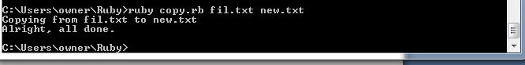

1. Notice at the end of the *What You Should See* I used something called cat? It's an old command that "con*cat*enates" files together, but mostly it's just an easy way to print a file to the screen. Type man cat to read about it.

**Ok.**

1. Find out why you had to write out_file.close in the code.

**Because after it has collected the object, there is no way to close the file anymore. So, closing files is highly recommended to retain manual control of your script/files behaviour, prevent unexpected behaviour caused by unpredictable output buffer flushing.**